SAFETY PLANS FOR UNITY SPIRITUAL CENTER OF LANSING FEBRUARY 2024

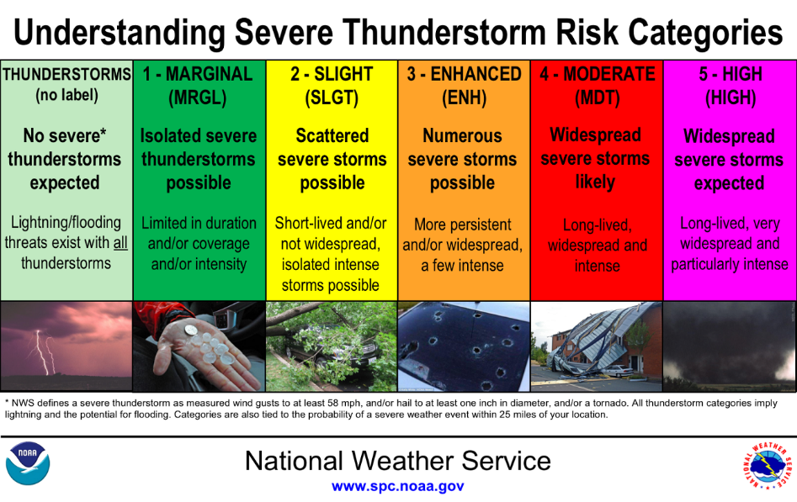
TORNADO/EXTREME WEATHER THREAT

An announcement will be made: “Attention Please. A Severe Weather Protocol is in effect. Go to your designated areas"

1. Designated staff will direct people to the kitchen
2. As overflow occurs, the men will be directed in the men's restroom and the women in the women's restroom
3. The designated staff will make a sweep of the building to make sure everyone is in place
4. The doors will then be held in place with the door wedges
5. Once safe, the designated staff will announce “all clear”

Nice to haves:
Vests to identify the designated staff
Walkie talkies to talk to each other to say the building is clear in all the areas (They can be the cheap toys, because it is not a huge area)

BUILDING FIRE PREPAREDNESS

An announcement will be made: “Attention Please. A Fire is in the building. Go to the Labyrinth."

1. Designated staff will direct people out the nearest doors
2. The designated staff will make a sweep of the building to make sure everyone is out
3. Once safe, the designated staff will announce “all clear” OR follow Firefighters instructions

Note:
Avoiding Parking lot for Fire Trucks
Used Labyrinth as a landmark for people. They may go past that.

Nice to haves:
Vests to identify the designated staff
Walkie talkies to talk to each other to say the building is clear in all the areas (They can be the cheap toys, because it is not a huge area)

ACTIVE SHOOTER PREPAREDNESS

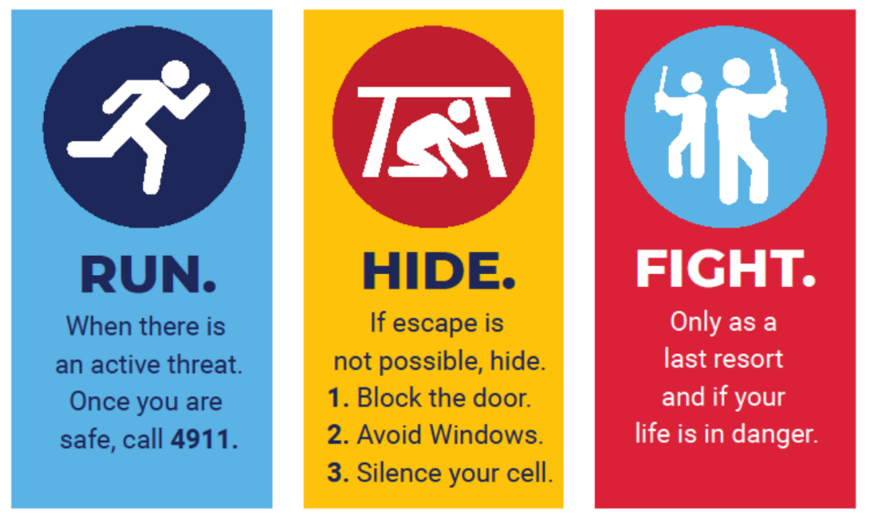
IF YOU SEE SOMETHING,
SAY SOMETHING

Be aware of your surroundings. Report suspicious activity to Rev Sharon Ketchum or Donnette Pinkerton.

An active shooter may be a stranger, a current, or former member. Alert Reverand Sharon Ketchum, Donnette Pinkerton or Edmund Mack if someone exhibits potentially violent behavior. Indicators of potentially violent behavior may include one or more of the following:

- Direct or veiled threats of harm or violence
- Intimidating, belligerent, harassing, bullying or aggressive behavior
- Increased severe mood swings and noticeably unstable or emotional responses
- Increase in comments about violence, firearms and other dangerous weapons and violent crimes

IF AN ACTIVE SHOOTER IS IN YOUR VICINITY:

RUN
- Have an escape route and plan in mind
- Leave your belongings behind
- Keep your hands visible

HIDE
- Hide in an area out of the active shooter’s view
- Block entry to your hiding place and lock the doors

FIGHT
- As a last resort (and only if your life is in imminent danger) fight
- Attempt to incapacitate the active shooter
- Act with physical aggression and commit to your actions

